Little SPARK: Simple Play Adaptations to Reference for Kids

Sensory Twists
Description: | Image:
A sensory seat cushion designed especially for sensory seekers! Spiky on one side and bumpy on the other, so kids can choose which type of tactile input they prefer.  Purchasing Information | 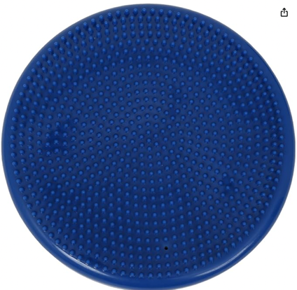

Who Might Benefit?
Those who need sensory input, mild movement, or balance challenges to stay focused and maintain a functional seated posture during activities.
Why Use?
Supports a “ready to work” posture, allows movement while seated, encourages self-regulation, improves balance, posture, body awareness, and enhances sensory processing skills.
Instructions for Use: | Adaptation Ideas:
Environmental Considerations  - Use in all settings, on the go, and in group and one-on-one activities.  Positioning/Alternate Positioning  - Use in any position; seated, standing, on the floor, under the feet, as a backrest etc.  Basic Play/Use Extended Play/Use  - Use in a chair or on the floor for seated activities. Sit and reach games for balance play.  Play/Use with Others  - Take turns tossing a ball or bean bag from the cushion or other turn taking games. | Stabilize It  - Dycem or shelf liner to stabilize the cushion on any surface.  Contain It  - Use on a chair with arms to provide more trunk support and less sliding.  Add Sensory Cues  - Use either side of the cushion, smooth spikes or small bumps.  Communication Supports  - Visual supports like communication cards and social narratives can help a child communicate their feelings.  Alternative Uses  - Include in an obstacle course and other gross motor and balance activities.  DIY Alternatives  - Minimally/moderately inflated beach balls for needed amount of movement. Not the ideal alternative for assisting with “ready to work” posture and not as durable.

Words to Encourage Play/Use
Sit  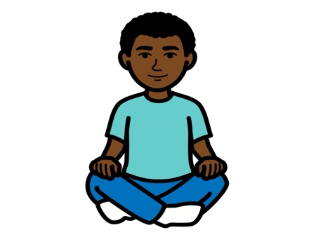 | Here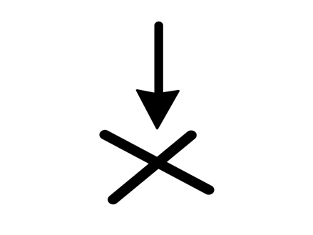 | Ready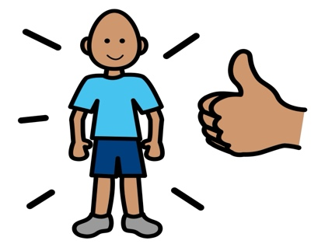
Move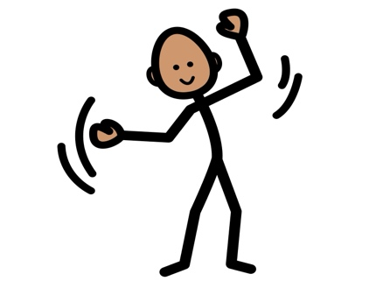 | Stand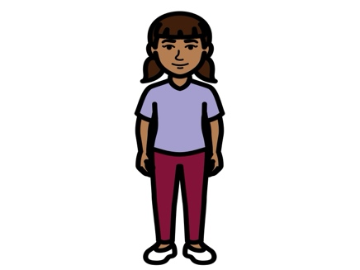 | Chair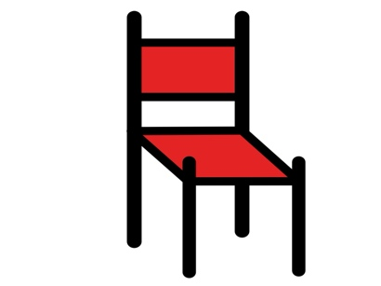
Touch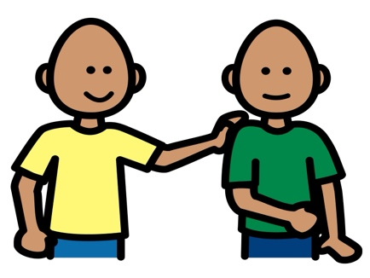 | On  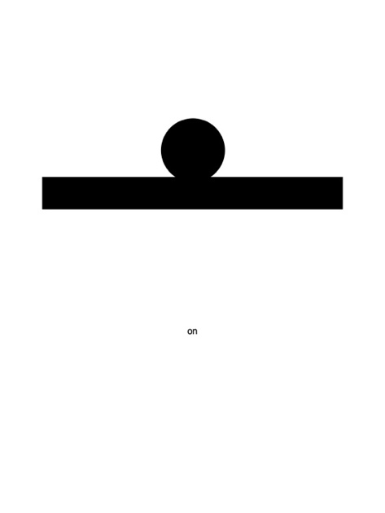 | Off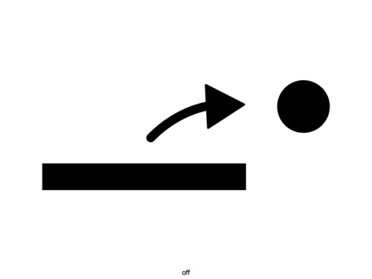
*”Adaptations” adapted from: Haugen’s Modes for Adapting Toys based on materials from the "Let's Play" Project at the University of Buffalo
PCS is a trademark of Tobii Dynavox, LLC. All rights reserved. Used with permission.

